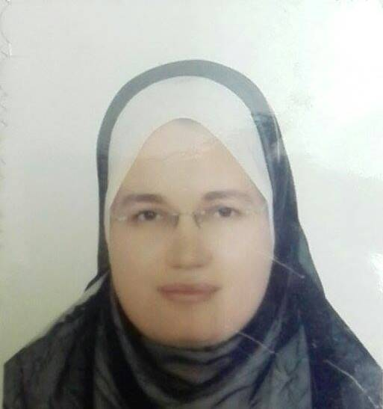


Assiut University
Faculty of Medicine
Dept. of Internal Medicine
CURRICULUM VITAE

Mona Hussein Ahmed El-Zohri
Consultant of Internal Medicine,
Lecturer of Internal Medicine,
Assiut University Hospitals and School of Medicine
Assiut, Egypt
Postcode: 71526, Assiut.
Tel: Home (+2088) 2146171, (+2088) 2312546
Office (+2088)2413234, (+2088) 2413774
Fax: (+2088) (2333327)
Mobile: (+2)01006249078
E-Mail: mona.elzohri@yahoo.com

Name: Mona Hussein Ahmed El-Zohri

- Birthdate: February 11th,1980.
- Sex: female.
- Nationality: Egyptian.
- Place of Birth: Assiut, Egypt.
- Marital Status: Married with three male and one female offspring.
- Professional Title and Address:
Lecturer of Internal Medicine, Faculty of Medicine, Assiut University, Egypt.
- Present occupation:
- Lecturer of Internal Medicine , Assiut University Hospital, Assiut University, Egypt.
- Lecturer of Rheumatology unit, Faculty of Medicine, Assiut University, Egypt.

- Subspecialty:
Rheumatology and Clinical Immunology.
- Educational Background:
  - September 2002: M.B.B.Ch in Surgery and Medicine, Faculty of Medicine, Assiut University, Egypt. (With general grade of Excellent with Honor).
  - November 2007: M.Sc. in Internal Medicine, Faculty of Medicine, Assiut University, Egypt.
  - November 2013: M.D. in Internal Medicine, Faculty of Medicine, Assiut University, Egypt.

